**Create and deploy Azure Resource Manager templates by using the Azure portal**

**Process 1:**

1. **Crearte a resource group.**
2. **Goto new resource -> storage account -> Add new ->**

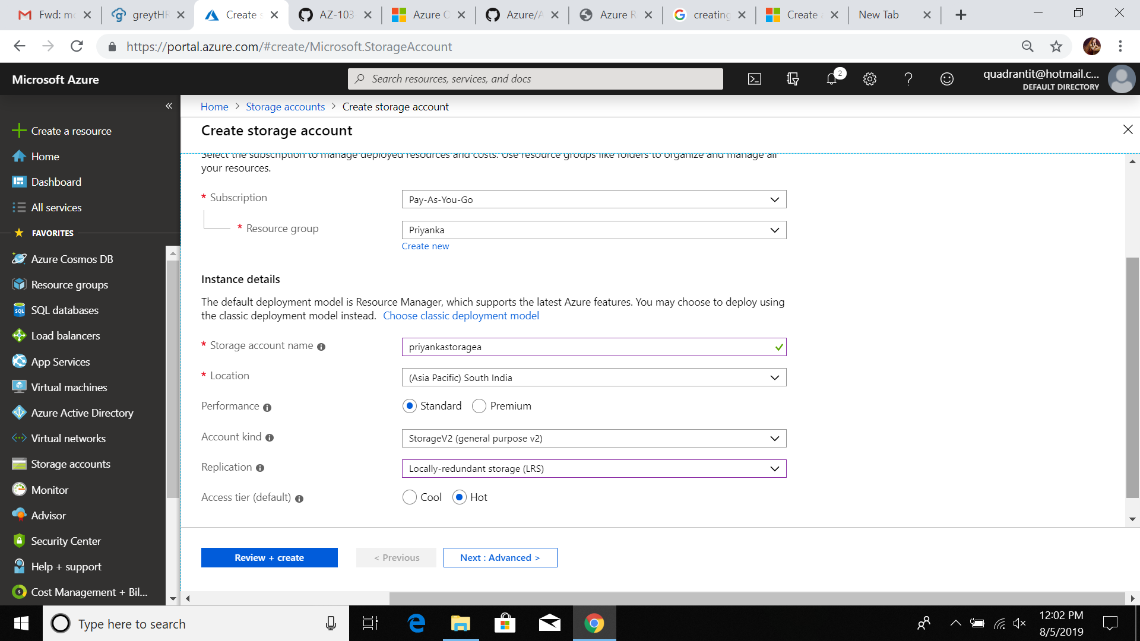

1. **Click review and create ..**



**After validation download the template.. its shows below the tab**

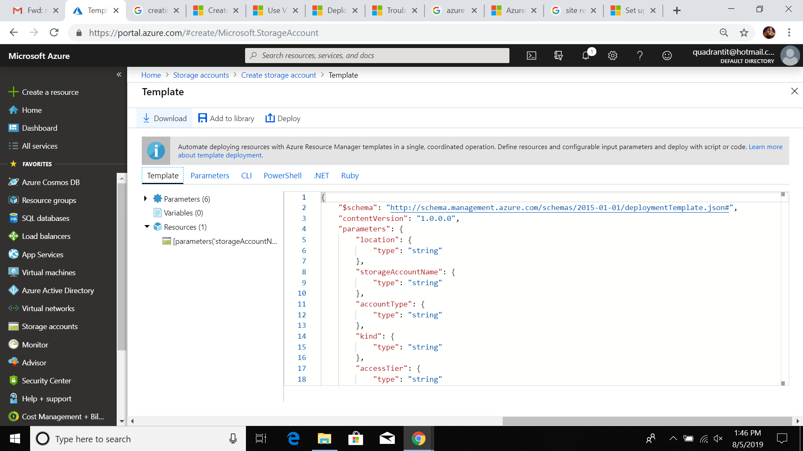

1. **Extract that warfile**
2. **Open deploye coustom template**

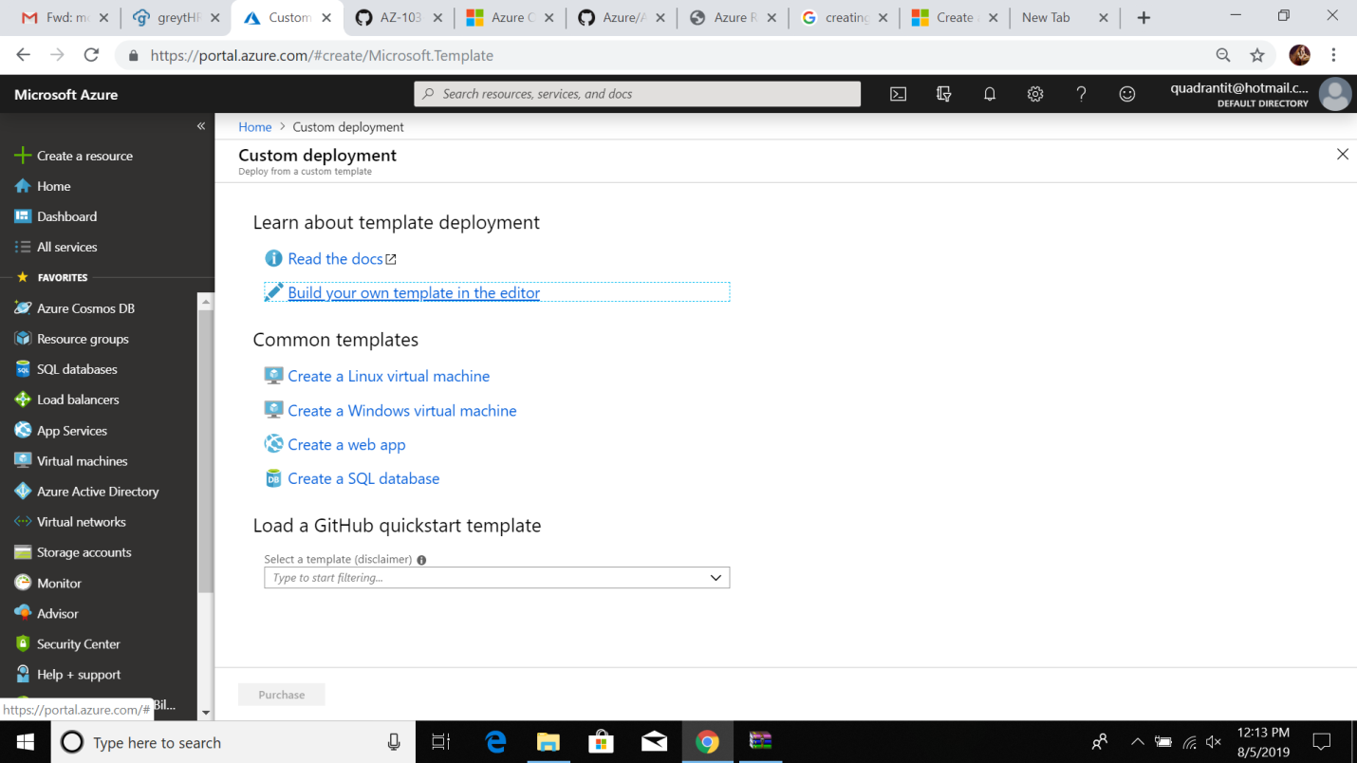

**7.click on build your own template**

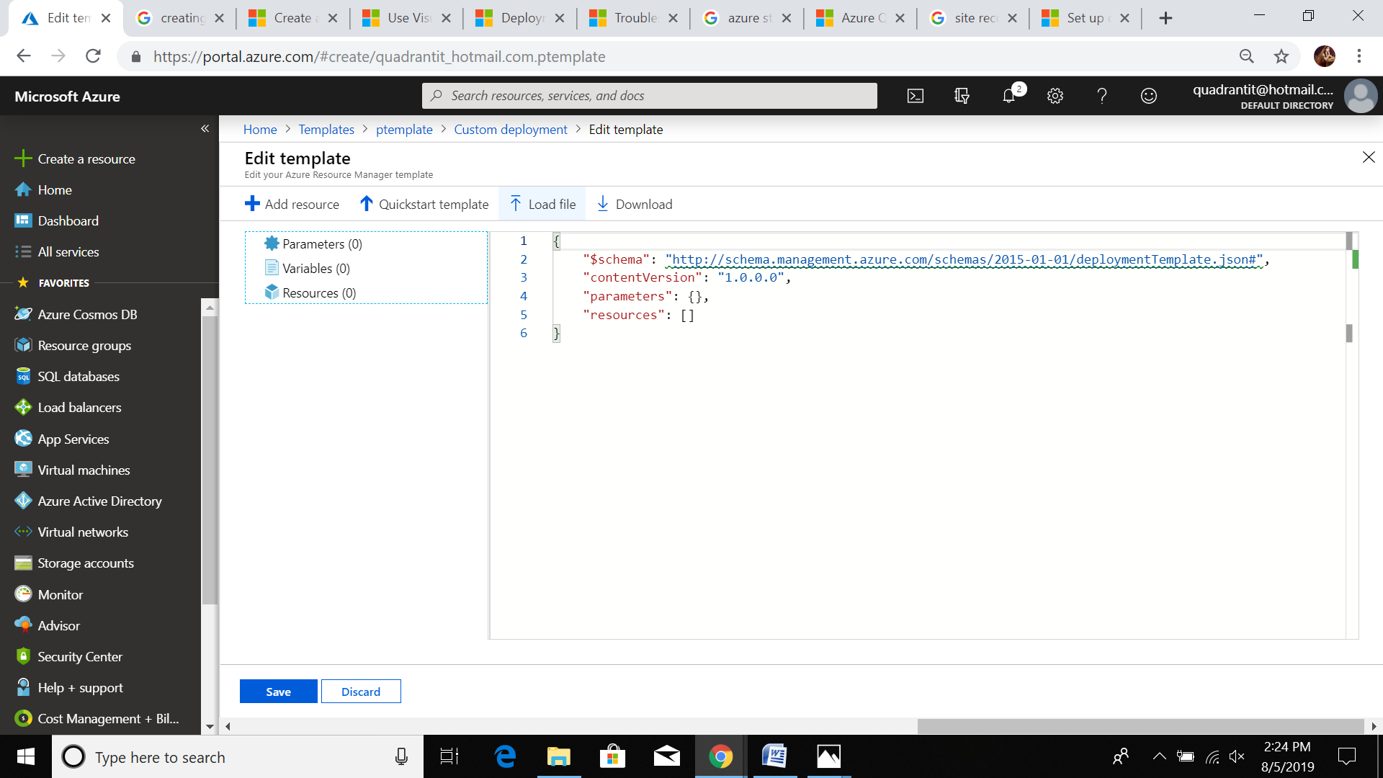

**Here click loadfile here we give custome template path.**



**8.In this we made some changes..**

**1.remove the storageaccount name parameter**

**2.** Add one variable called **storageAccountName**

**"storageAccountName": "[concat(uniqueString(subscription().subscriptionId), 'storage')]"**

**3.** Update the name element of the **Microsoft.Storage/storageAccounts** resource to use the newly defined variable instead of the parameter

**"name": "[variables('storageAccountName')]",**

1. **Click save**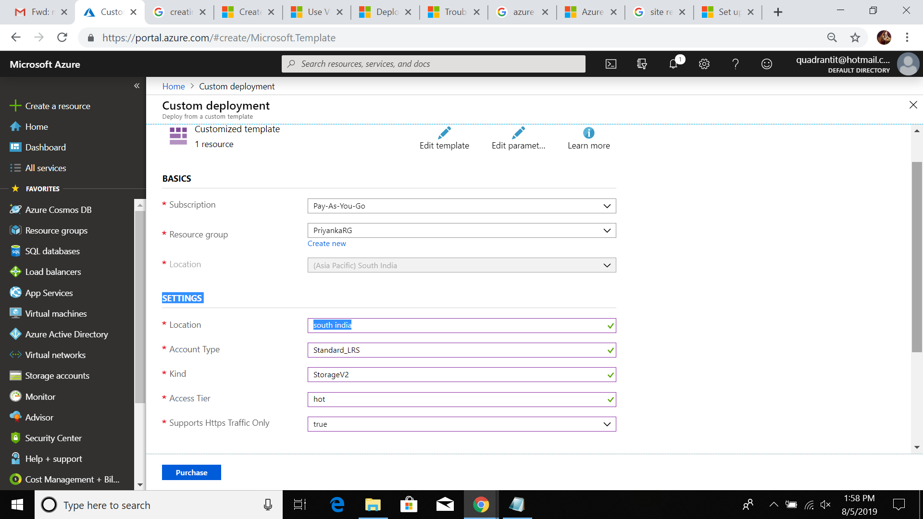
2. **Give the required parameters click purchase**

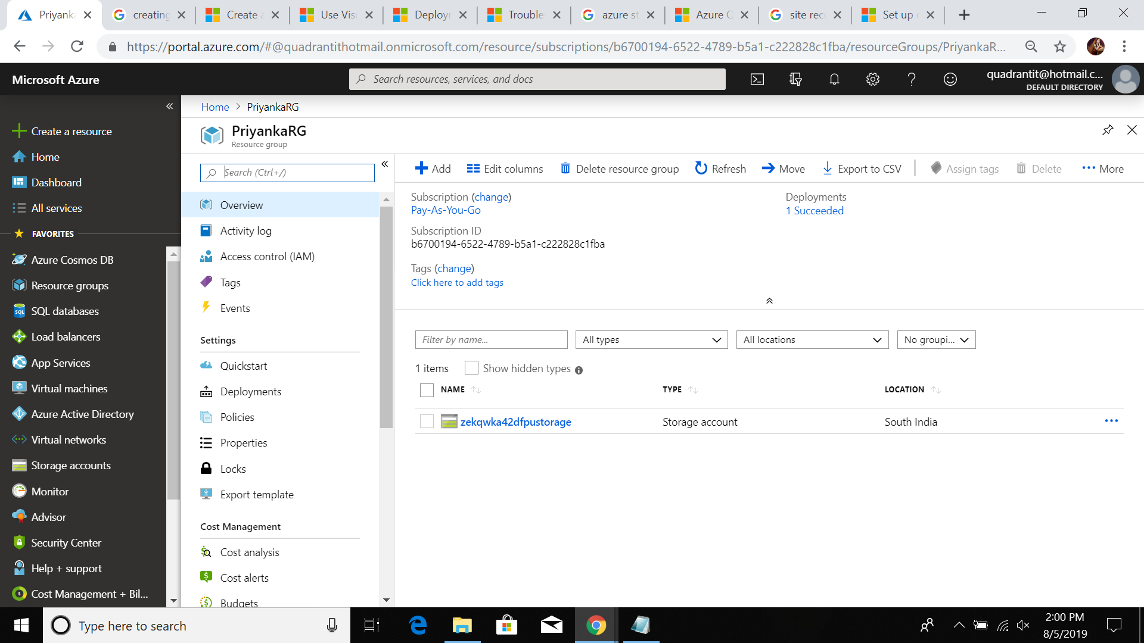

**Process 2**

1. **Goto templates -> add new templates- >**

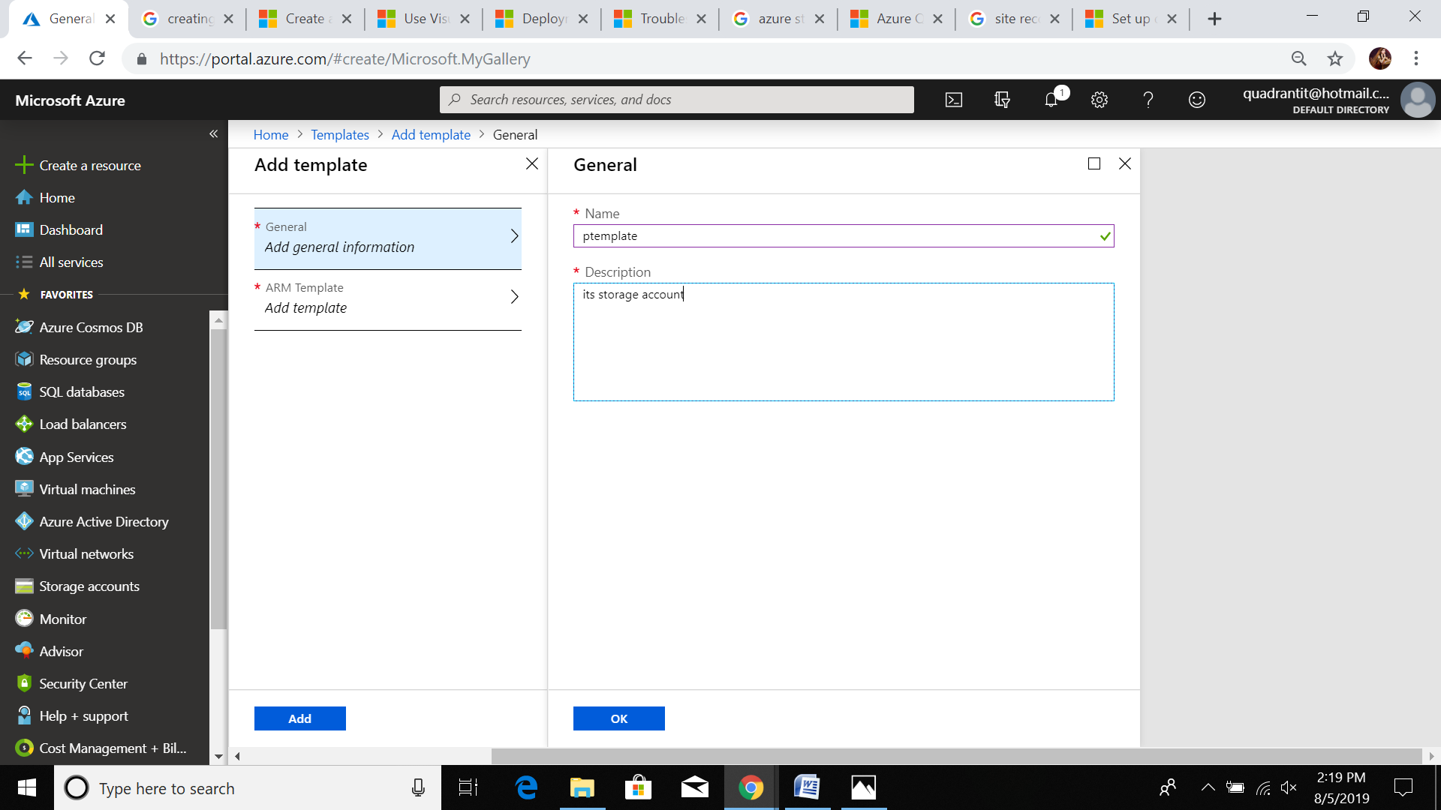

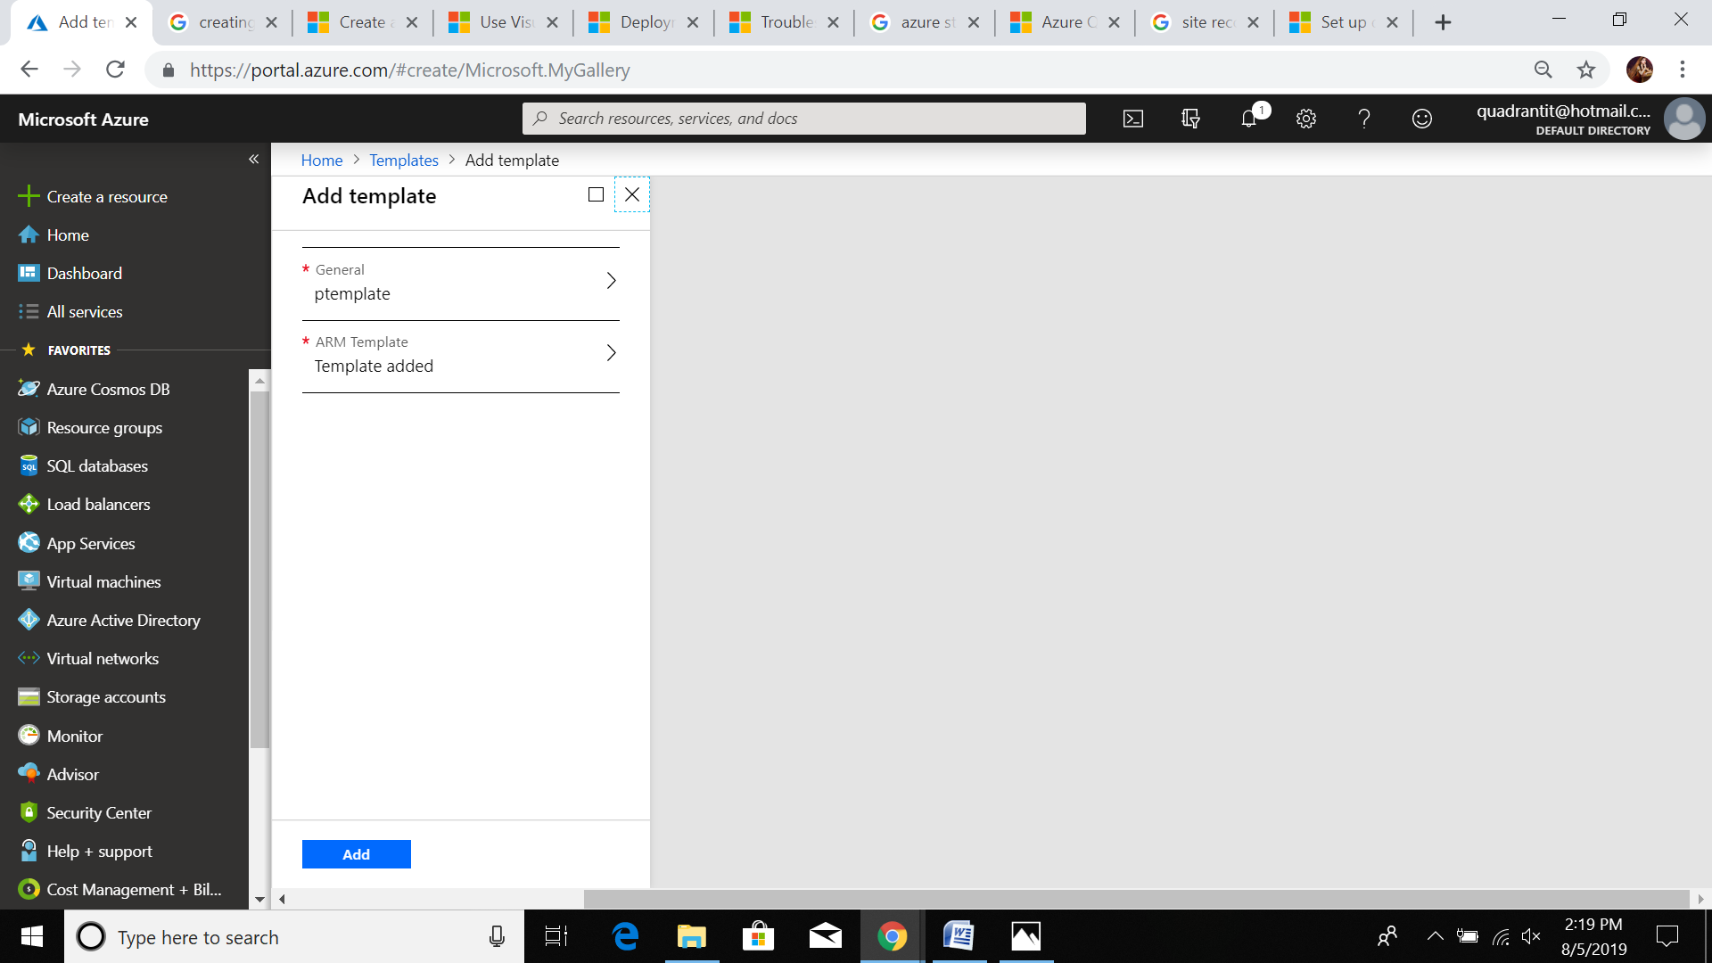

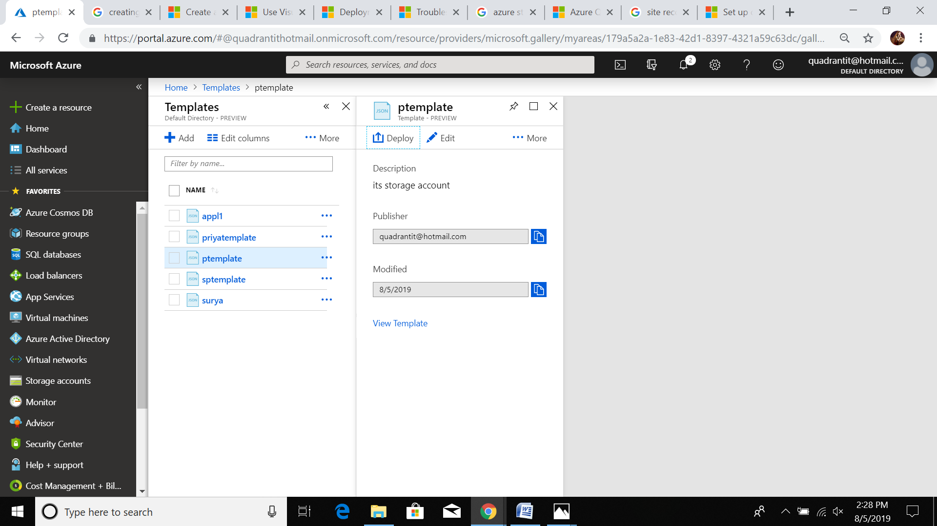

**Click here deploye .. remaing same as above prcoess 1.**